NAME : SHEEFA NAAZ
DATE: 02-11-2023
AP LAB 8

Q1>Reading the data.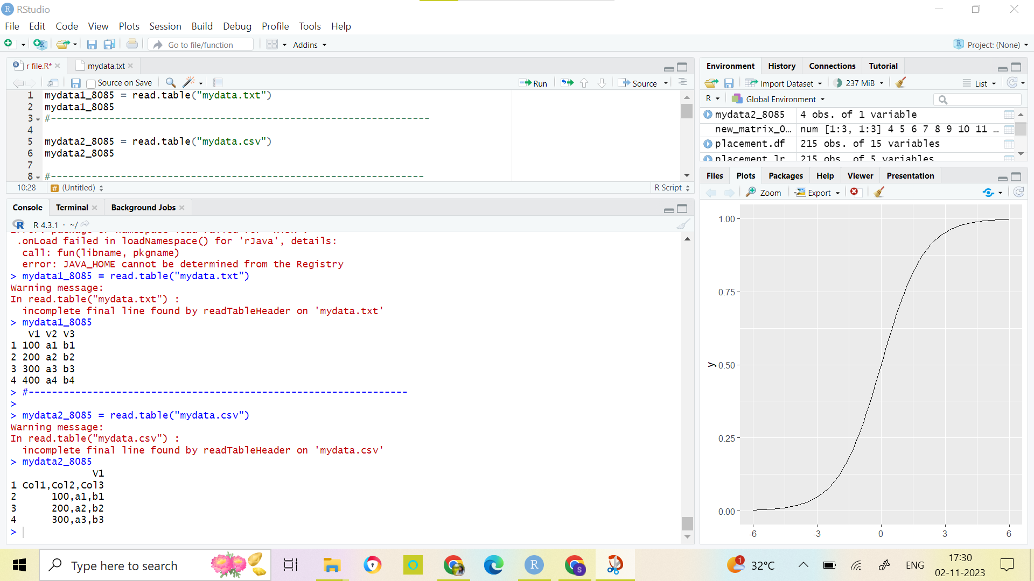

Q2>>> Installing the package and data visualization
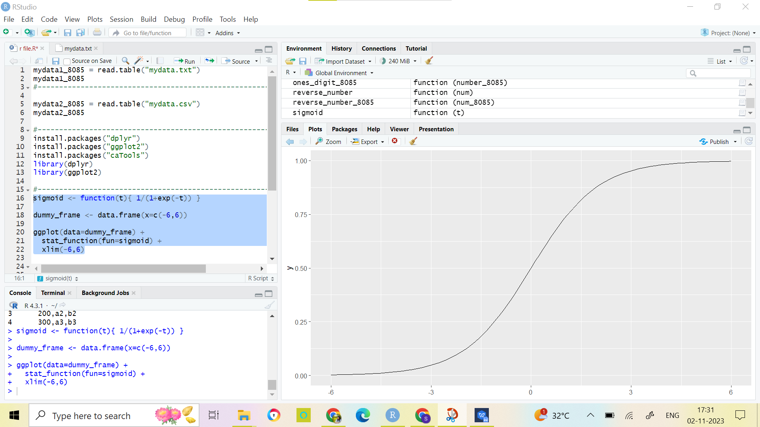

Q3>>Reading the gender submission csv file.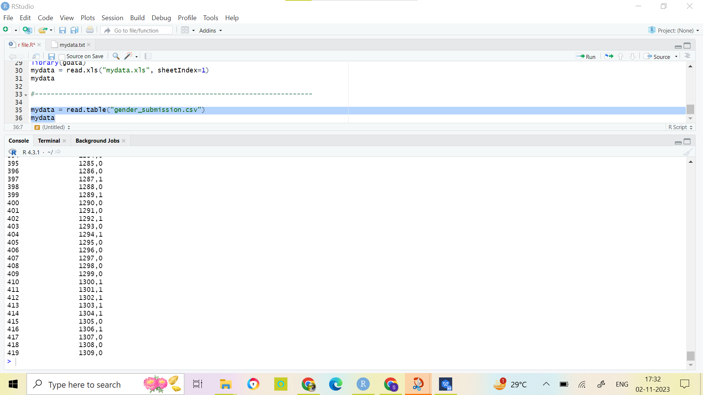
Q4>> Reading the Xl file.
